De Bohun Primary School & Children’s Centre

Assessment Policy

Written by Mr Dominic Smart 2017

The purpose of assessment

We assess so that:

- Teachers can assess what children know, understand and can apply to their work.
- Teachers can plan learning opportunities that reflect the needs of all children.
- We can identify children who are falling behind and plan support to address their needs.
- We can identify children exceeding their age related expectations and plan work to extend them further.
- We can provide parents with information about their child’s learning.
- We can provide useful data for analysis, whole school planning and accountability.

Elements of assessment at De Bohun Primary School

Yearly:

Nationally standardised summative assessments
- KS2 SATS
- KS1 SATS
- KS1 Phonics Screening Check
- EYFS attainment

Basleine assessments

For the first two weeks of every new academic year, teachers are given the opportunity to baseline all children against the end of year expectations for their year group. This ensures each teacher has an accurate starting point for each child and can plan to meet the needs of their children.

Termly:

Pupil Progress Meetings
Pupil progress meetings between class teachers and members of the Senior Leadership and Senior Management Teams happen once each term. These meetings are to establish how the children are performing in relation to their age related expectations and to find ways to ensure that all children are supported in their learning in a manner that reflects their individual needs.
Children that may be in danger of falling behind are also identified; the team are then able to discuss how these children might be supported to ensure they make accelerated progress. Likewise, children that are exceeding age related expectations are discussed and extension work put in place as appropriate. Teachers are held accountable for the children’s progress during these meetings. End of year targets are also set and agreed, which form part of the Performance Management cycle.

Target Tracker
De Bohun’s internal data is collected termly. Teacher’s summative judgements every term are recorded against the following criteria:

S+ Working at greater depth within ARE objectives - Secure
S Working at greater depth within ARE objectives – Beginning (All yellow/most green)
W+ Working at ARE objectives - Secure
W Working at ARE objectives – Beginning (All red/most yellow)
B+ Working towards ARE objectives - Secure
B Working towards ARE objectives - beginning

Teachers judge the attainment of the children in reading, writing, maths and Science. At De Bohun, we expect that children make at least two steps of progress a year. For example, a children attaining B, will be expected to be working at W by the end of the year. Accelerated progress is three steps, for example a child who moves from B to W+. Two steps of progress is good progress. Three steps of progress is outstanding progress.

Testing

There are a range of termly tests used by teachers to form part of summative and formative judgements. We currently use:

Maths:
- KS1 and KS2 past papers
- Test base
- Twinkl assessments
- De Bohun’s bespoke number assessment

Reading
- KS1 and KS2 past papers
- NFER Testing
- Accelerated reader assessments

Phonics
- Phonic Passports
- Past phonic screening check materials

Early Years

In our Early Years settings colleagues record assessment information using Target Tracker. This is an ongoing assessment of each child in relation to the Early Year Foundation Stage Profile. Parents and carers are provided with training on this tool and can access the information from home. Assessments are also made using English and maths books as well as Special Books.
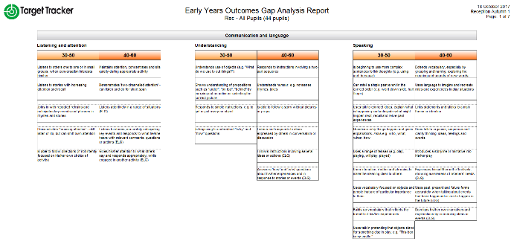
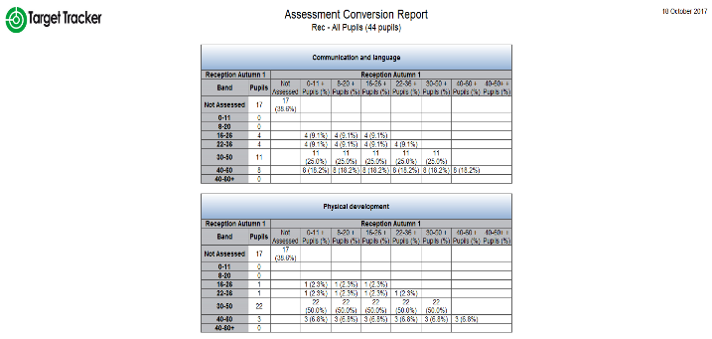

Daily

Climbing the Mountain to Success teaching model
Please refer to the ‘Climbing the Mountain to Success’ teaching model document (appendix 1).

Feedback and Marking

Please refer to the ‘Feedback and Marking’ policy (appendix 2).

Mind the Gap Assessment Tool

De Bohun have developed an on-line teacher assessment tool to be used as a way of formatively assess pupil progress. The expectation is that teacher’s use this programme as an on-going assessment tool to support in ensuring that the individual needs of each children are met. The colours shown below link to the attainment of the children (please refer to the section previously ‘Target Tracker’). Children who have not yet met the objective are given intervention to ensure the ‘gap’ in learning is addressed.
Foundation Subjects

Located in the back of every foundation subject book is a skills progression map for each subject. During an INSET day on Friday 10 February 2017 it was agreed by all teaching staff that we would assess foundation subjects in the following way:

- The objectives covered in each unit of work will be highlighted, directly into the child’s book, at the end of each unit of work.
- The objective will be highlighted based on the child’s attainment.
- The same colours used across the school will apply (red – beginning, yellow – working at, green – great depth).
- When a child moves onto the next book, a colour photocopy of the skills grid will be placed in the child’s new book.
- The attainment of the children will be used by the current and subsequent teacher to plan to address the gaps in understanding.

SEN

Some children may be significantly below their age related expectations because of their SEND. For such pupils it is important to assess their learning using a wider range of tools. This may be different for every child but could include assessment information regarding their spelling or reading age. As with all children, pupils with SEND should be set targets that reflect their individual needs. They have a Learning Passport which details specific targets for them to work towards. Any assessment of their progress should take account of achievement against their Learning Passport targets. Children with SEND can also be assessed in regard to their progress within particular learning interventions that take place across the school. The Inclusion Team also use our Mind the Gap assessment tool to break down objectives into achievable steps. SEND tracking is held by the Inclusion Team.

The Role of Governors

Governors have a crucial role in ensuring the school has accurate assessment information for all children. Although Governors will not know individual children’s results, it is essential that governors are aware of how groups of children are performing and the progress they are making. The school will report to the governors termly on progress made in each year group and for each identifiable group of children. The school will provide thorough and accurate reports and analysis on the performance of children against national expectations at the end of Key Stage 2 and the school must provide robust action plans following each year’s results. Governors will provide challenge for the school and will meet regularly with the Assessment Leader to review progress. Outcomes and progress measures will be reported to the Teaching and Learning sub-committee.

National standardised summative assessment

Nationally standardised assessments will be used to provide information on how children are performing in comparison to children nationally. They will provide parents with information on how the school is performing in comparison to schools nationally. Teachers will have a clear understanding of national expectations and assess their own performance in the broader national context. Nationally standardised summative assessment enables the school leadership team to benchmark the school’s performance against other schools locally and nationally, and make judgements about the school’s effectiveness. The government and OFSTED will also make use of nationally standardised summative assessment to provide a starting point for Ofsted’s discussions, when making judgements about the school’s performance.

A range of ‘Nationally standardised summative assessments’ will be used:
- A phonic screening test in Year 1
- National Curriculum teacher assessments at the end of Key Stage 1
- National Curriculum tests at the end of Key Stage 2

Reporting
The school has a well-established system for reporting to parents. This consists of:
Autumn Term - parents are invited to attend a consultation evening where the child’s progress towards settling into a new academic year and end of year targets are discussed. Baseline reports are given to parents/carers during this meeting.
Spring Term - parents are invited to attend a second consultation evening where the child’s progress is discussed in terms of age-related and personal expectations.
End of Summer Term - parents receive a full written report which includes details of the child’s achievements and progress for the academic year.
Statutory Assessments – all statutory assessments are reported to parents at the end of the academic year, included within the full written report in the Summer Term. This includes, EYFS attainment, KS1 Phonics Screening Tests, KS1 outcomes and KS2 SATS test outcomes.

Monitoring
This policy is designed to ensure that children’s needs are reflected in planning and teaching across the school and that whole school improvement is effective. The policy will be reviewed every two years or sooner in light of changes from the DfE.

