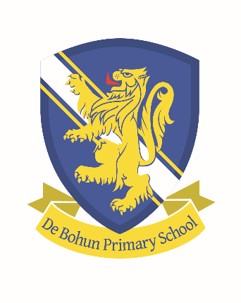
An Overview of British Values at De Bohun Primary School

Democracy

We have an active School Council and every child is given the opportunity to represent their class on the School Council. Children have to present to the class why they would be a good School Council member and are then elected through a secret ballot. Our School Council have redesigned the school logo and spent over £10,000 to improve the playground. A number of stakeholder surveys this year have been used to vote on key school decisions, through our school APP. In addition to this, children and parents complete an annual questionnaire where they are able to put forward their views and opinions about the school.
Children’s voice is also a key part of our work in school, and children are encouraged to give their opinion on a wide range of different areas of the school. A key area of this is through their work and our Enhancing Learning Outcomes Model. Children are given the freedom to choose their starting points and decide when they are ready to move on to tougher challenges.
We also join debates with other schools and encourage children to share their opinions and to justify them, and to respect those of others.

The Rule of Law

The importance of laws, whether they are those that govern the class, the school, or the country, is consistently reinforced at De Bohun. Pupils are taught from an early age the rules of the school. These are our Golden Rules. Pupils are taught the value and reasons behind rules and laws: that they govern and protect us, the responsibilities that this involves and the consequences when laws are broken. Children are taught that ‘every action has a consequence.’ Visits from authorities such as the Police and Fire Service help reinforce this message.

Individual Liberty

At De Bohun pupils are actively encouraged to make choices, knowing that they are in a safe and supportive environment. As a school we educate and provide boundaries for young pupils to make informed choices. Pupils are encouraged to follow the 6Rs (be responsible, resilient, resourceful and reflective, take risks and build positive relationships) and are given the freedom to make choices, for example taking part in our numerous extra-curricular clubs. Children understand that they have personal freedoms, but we educate them to ensure they exercise them safely, though lessons such as E-Safety.

Mutual Respect

Our school ethos and behaviour policy has revolved around core values such as 'Respect', and pupils have been part of discussions and assemblies related to what this means and how it is shown. Weekly circle time plays an active role in ensuring that the children understand and show respect towards each other. The school ethos and aims promote respect for others and this is reiterated through our classroom and Golden Rules, as well as our behaviour policy.

Tolerance of those of Different Faiths and Beliefs

De Bohun is a diverse and multicultural school. We celebrate Black History month and recognise the achievements of people from different cultures and religions. We actively promote diversity through celebrations of different faiths and cultures. Religious Education and PSHCE lessons reinforce messages of tolerance and respect for others. Members of different faiths and religions are encouraged to share their knowledge to enhance learning within classes and the school. The children visit places of worship that are important to different faiths. We also have theme assemblies and weeks where we celebrate and learn different cultures and beliefs.

