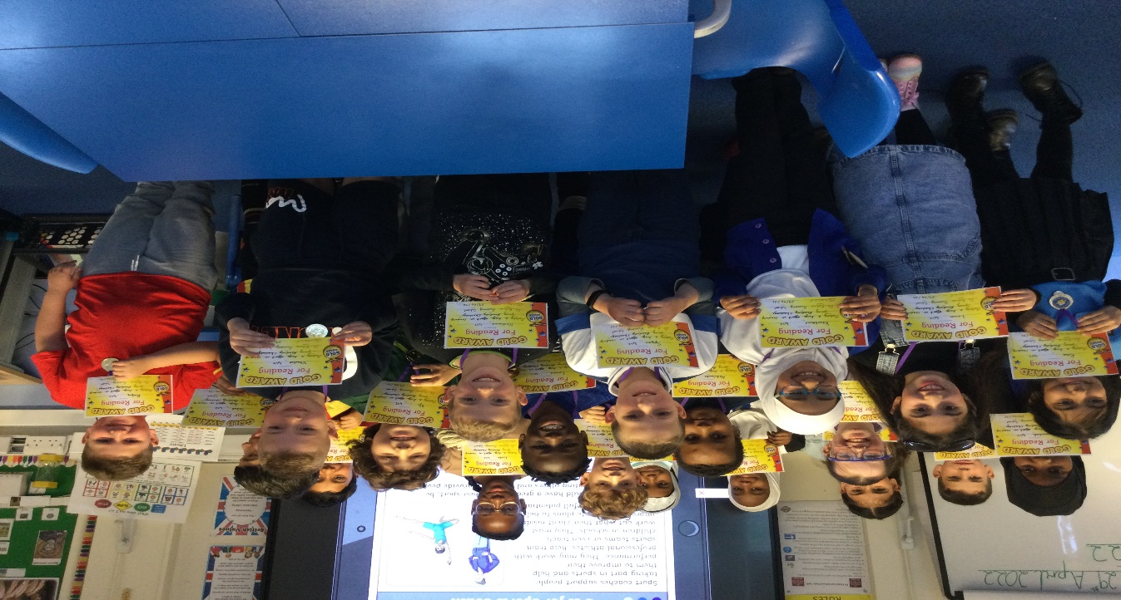

As you will all know here at De Bohun School we really encourage our children to read as much as possible and so during the Spring Term we ran a Reading Challenge.

I am very pleased to announce that 4SZ, Mrs Zaman, is the winning class of the Spring Reading Challenge. The decision was made on the whole class joint effort in reading, quizzing and achieving the higher amount of books read on Myon at home and in school. Certificates, medals and the prize of £100 were presented to 4SZ during assembly. Well done 4SZ.
Well done also to 5KL, Miss Loizou, who came in second place, they too made a huge effort in reading, again judged on the amount of books read on myOn at home, quizzing and reading in school. Children were given pens and certificates for their achievement. Well done 5KL.

Thank you to all children for taking part in our Spring Reading Challenge and Congratulations to all the winners.

Mrs.Tsirpi, School’s Reading Specialist

